STUDENTS PARTICIPATION IN SPORTS ACTIVITIES
2022 - 2025

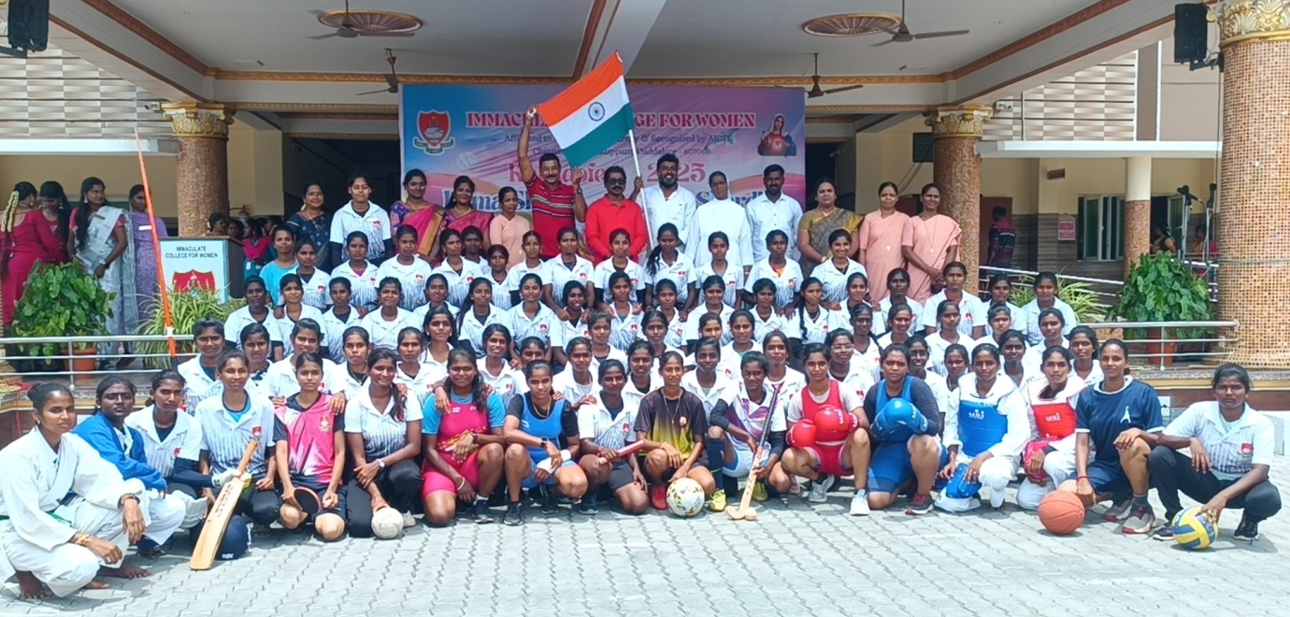

ANNUAL SPORTS REPORT
2022 – 2023

ANNUAL SPORTS REPORT
2022 – 2023
Athletics Meet – 18.09.2023
Our college 15 students had participated in the in the Anna Stadium, Cuddalore. In that, 10 students won 13 Medals & Certificates. They were
- Savitha won 3rd prize in Hurdles
- Kajalakshmi won 3rd prize in 800 M
- Megadharshini won 3rd prize inn Discuss Throw
- Viyanni won 2nd prize in 800 M
- Niranjana won 1st prize in shot-put and 2nd prize in Discuss Throw
- Thamizh Semmozhi won 3rd prize in Shotput and 1st prize in Discuss Throw
- Sivabharathi won 3rd prize in 400 M
- Girija won 2nd prize in 400 M & 3rd prize in Long Jump
- Vanathi won 2nd prize in 1500 M
- Kaviya won 3rd prize in 400 M
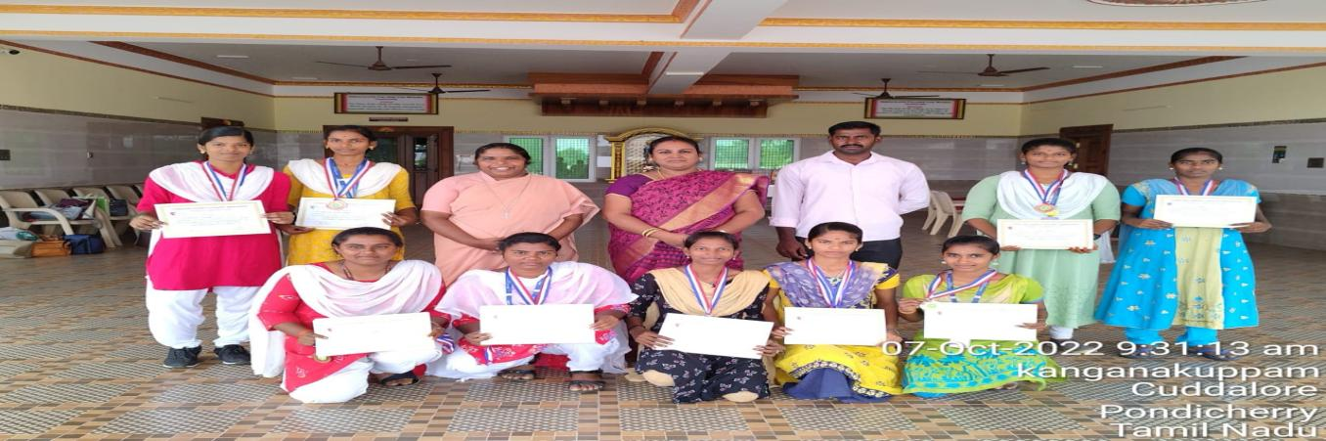
HOCKEY – 08.11.2023
Our Collegiate students had participated in the Hockey Match at Divisional Level. It was held at St. Joseph’s College, Cuddalore. Our Hockey team win 1st place and the team was selected for the Inter-Division.
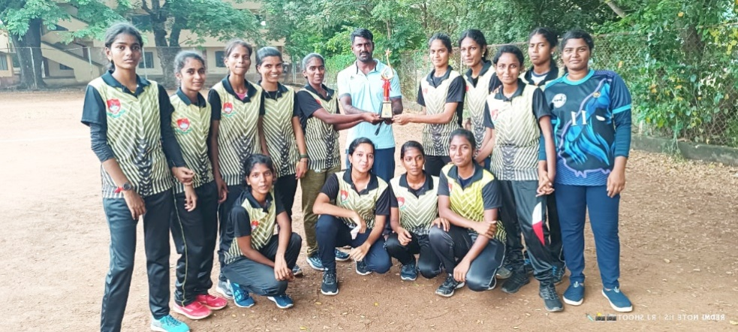
Hockey - 24.12.2022
Our college student Girija. R rep1resenting Hockey game got FORM III in Tamil Nadu Ambedhkar University and played in South Zone Inter University.
Kho-Kho - 22.01.2023
Our college student Parameswari got FORM III in Kho-Kho event in the Alliance University, Bangalore under Annamalai University.
Ball Badminton - 26.01.2023
Our college student Nivetha. G got FORM III in the event of Ball Badminton in Chennai.
SILAMBAM - 06.02.2023
Our college student Priyatharshini had participated in the state match representing the game of Silambam and won 2nd place in the event.
CRICKET - 17.02.2023
Our college had participated in the CM TROPHY events representing the game of Cricket and won 1st place.
HOCKEY, ATHLETICS & TABLE TENNIS - 19.02.2023
Our college students had participated in the Day 3 CM TROPHY events (Hockey, Athletics & Table tennis). In these events, our students won in Shot put (Niranjana – 3rd Place), 100m Hurdles (Priyatharshini – 2nd place) and Discuss Throw (Niranjana – 2rd Place). And also won 3rd place in Table tennis (Doubles) – Sridevi & Nivedha.
SILAMBAM - 24.02.2023
Our college student, Priyatharshini participated in the National level representing the game of Silambam and won 1st Prize in the event.
CRICKET - 09.07.2023
Our college Cricket team had participated in the CM Trophy event which was held at SRM University, Pour. In that our college team won 2 matches.
