ANNUAL SPORTS REPORT
2023 – 2024

DISTRICT ATHLETE MEET - 12.08.2023
Our college Student, 27 members participated in the District Athlete Meet. In that our students got 10 medals.
- A. Parameswsari (1500m) – 2nd place
- R. Arthi (100m hurdle) – 1st place
- S. Bhavadhini (100m hurdle) – 2nd place
- N. Rajashree (100m hurdle) – 3rd Place

- M. Sindhuja (800m) – 3rd place
- M. Revathy (Long jump) – 1st place
- V. Niranjana (shot put) – 2nd place
- V. Abinayasri (400m) – 3rd place
- A. Parameswsari (400m) – 2nd place
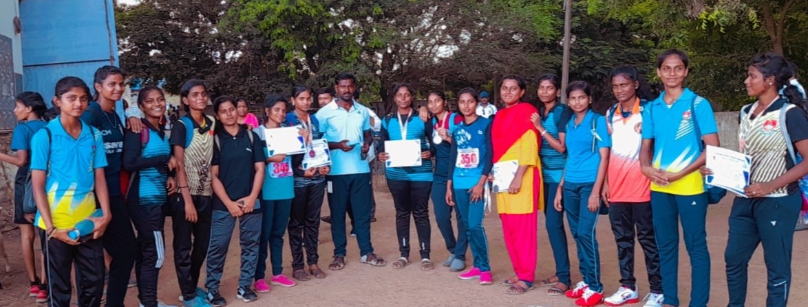
KARATE – 09.09.2023
On college student, K. Vanathi, had participated in the 2nd South Indian Karate championship – 2023 held at Thiruvananthapuram, Kerala. She placed 3rd Prize in that event.
ANNA MARATHON RACE - 07.10.2023
Various students from our college had participated in the Anna marathon race. In that, A. Parameswsari won Cash prize of ₹1000/-
NEITHAL MARATHON- 26.08.23
Our college student had participated in the NEITHAL MARATHON which is held at Periyar Arts and Science, Cuddalore. Totally 75 students were participated. In that A. Parameswari got 8th place.
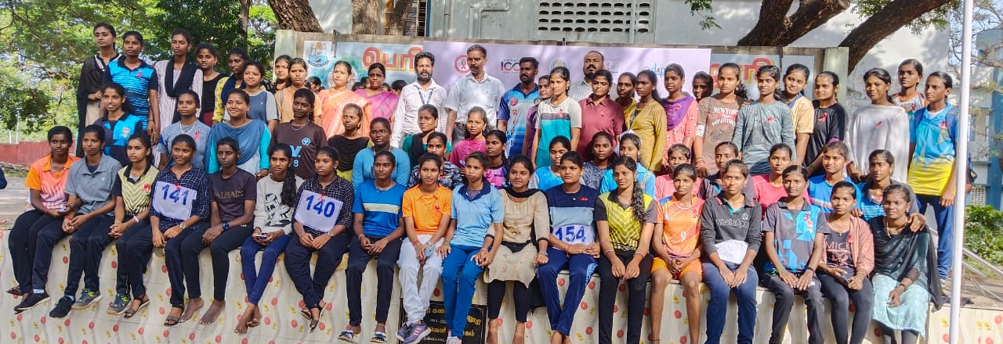
TAEKWONDO - 28.10.2023
Annamalai University conducted Taekwondo inter divisional tournament at Periyar Arts & Science College, Cuddalore.
- Punithavathi – 2nd place
- Sarojini – 2nd place
- Manikuyil – 3rd place

- Anushya – 2nd place
- Bhavadhini – 2nd place
- Thamizh Semmozhi – 2nd place
MINI MARATHON - 29.10.2023
Parameswari. A had participated and won 1st place in the Mini Marathon which was held at CK College, Cuddalore. She won cash prize of ₹1500/-
TABLE TENNIS - 01.11.2023
Our collegiate students had participated in the open tournament Table Tennis held at CK College, Cuddalore.
- Sridevi (Singles) – 3rd place
- Avitha & Pavadharani (Doubles) - 2nd place
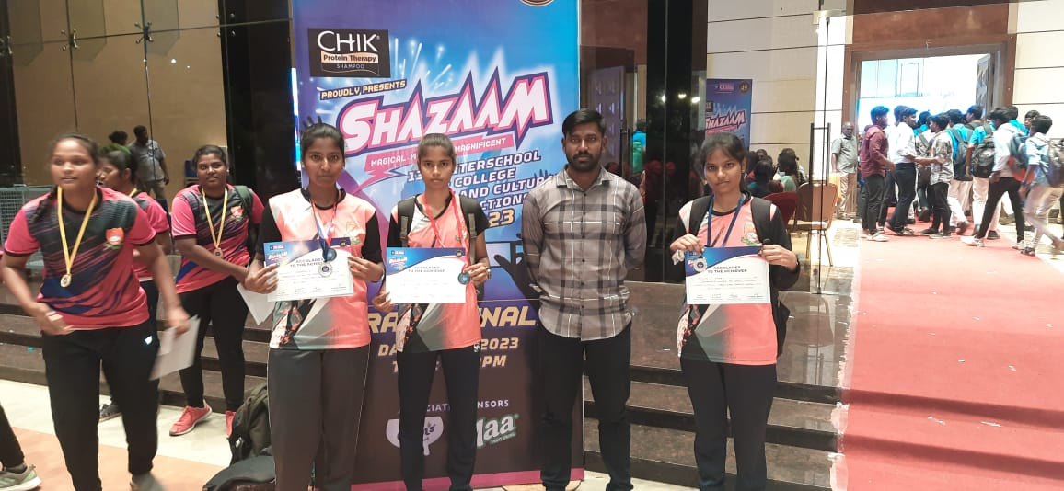
KABADDI, CRICKET AND VOLLEY BALL - 02.11.23
CK College of Engineering conducted open tournament in the games of Kabaddi, Cricket and Volley Ball. In that
- Kabaddi – 1st prize
- Cricket – 2nd prize
- Volley Ball – 3rd prize and also won cash prize.
BOXING - 07.11.23
Annamalai University had organized Inter- Divisional tournament on Boxing. In that, our college students were participated. They are
- Thamizh Semmozhi – 2nd place
- Srinithi. V – 3rd place

- Sarojini. A – 1st place
- Niranjana. V – 1st place
- Priyadharshini – 1st place
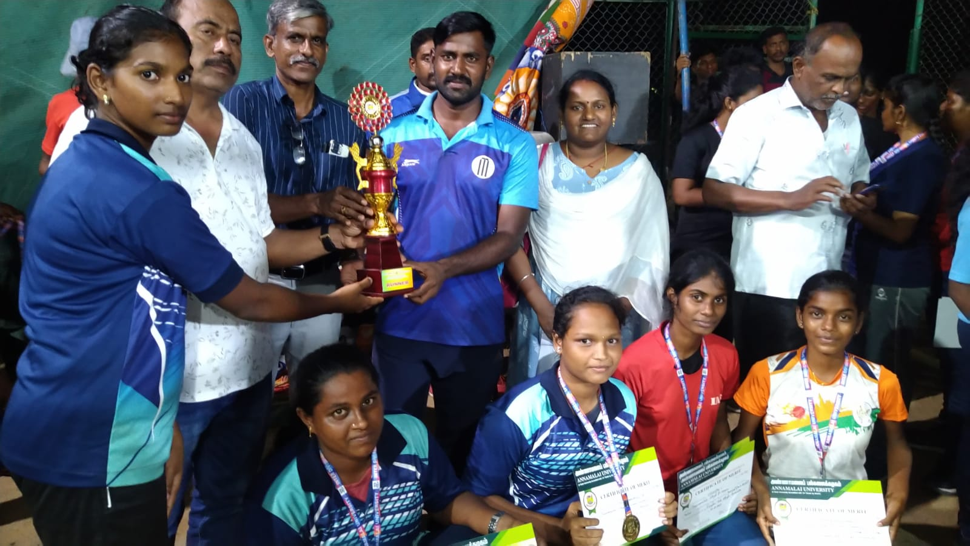
KHO -KHO - 25.12.23
Our college student Parameswari. A got FORM III in the event in Kho -Kho in Thiruvarur.
CRICKET - 11.01.2023
Annamalai University organized Cricket match in Chidambaram. Our college team participated and won 2nd place in the match and 5 players got selection for the University match.
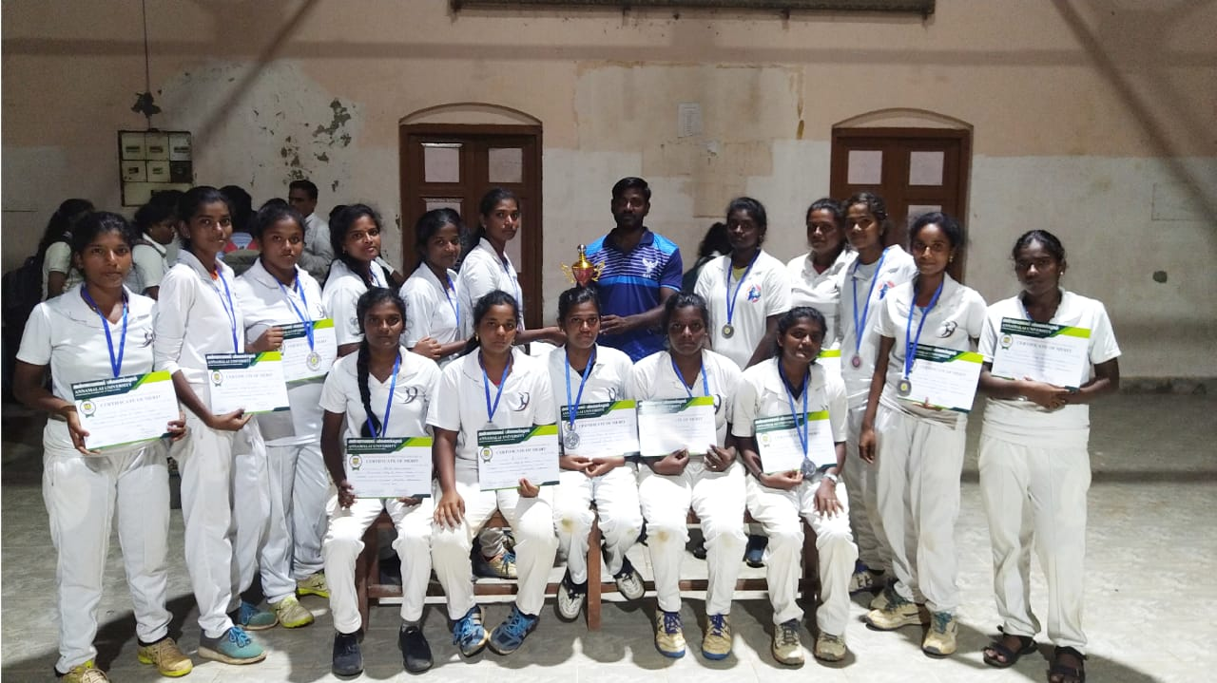
CRICKET (OPEN TOURNAMENT) – 13.01.2024
Our collegiate students had participated in the Open tournament which was held at Tagore Arts college ground, Pondicherry. In that, our Cricket team won 3rd place.
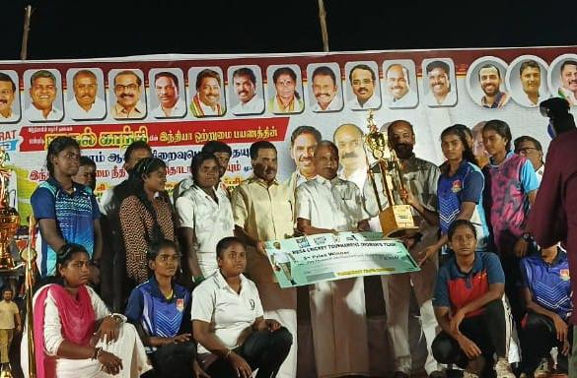
CRICKET – 16.01.2024
Our college 5 students got FORM III in the Cricket University match in the Alagappar University, Karaikudi. They were, Sarojini. A, Dhivya, A, Hema Mathivadhani. V, Niranjana. V & Buvana. S.
JUDO – 02.02.2024
Our college students had participated in Judo which was conducted by Annamalai University in the Periyar Arts & Science, Cuddalore. In that, our college won overall trophy and 7 medals.

- Rathipriya – Gold medal
- Sarojini – Gold medal
- Revathy – Gold medal
- Thamizh Semmozhi – Gold medal
- Bhavana – Silver medal
- Punithavathi – Silver medal
- Manikuyil – Bronze medal
JUDO – 02.02.2024
Our college students who won gold medal in JUDO, they were participated in the All India Match which was held at Amritsar, Punjab. They got FORM III in that event. They were Sarojini, Revathy, Thamizh Semmozhi & Rathipriya.
MARATHON – 18.04.2024
Our College students were participated in the Voter’s Day Marathon. In that, Parameswari won 10th place in the event.
WRESTLING – (08.03.2024 – 10.03.2024)
Tamil Nadu Amateur Wrestling Association had organized 10th Tamil Nadu State U-20 Wrestling Championship 2023-24, which was held at Mettur, Salem. In that, Savitha. S won Bronze in 50 Kg women’s freestyle.
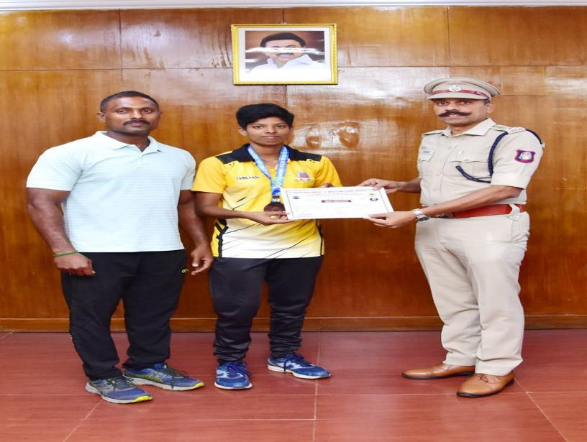
WRESTLING - 28.03.2024 & 29.03.2024
Tamil Nadu Amateur Wrestling Association had conducted 2nd Tamil Nadu State U-17, U-20 & Senior Beach Wrestling Championship which was held at Anthiyur, Erode. In that, Savitha. S won Bronze in 50 Kg Beach Wrestling under-20 Girls.

WRESTLING - 30.03.2024
Tamil Nadu Amateur Wrestling Association had conducted 4th Tamil Nadu State Senior Traditional Wrestling Championship which was held at Salem. In that, Savitha. S won Bronze in 50 Kg women’s Free style.
WRESTLING - 28.06.2024 & 29.06.2024
Savitha. S from our college won Bronze Medal in the 1st South India under-23 Wrestling championships – 2024. It was held at Johindra Sports Academy, Kaveri cross, Salem.

